Understanding Asynchronous _JavaScript and XML (AJAX)
Author: Lovin Vergheese

Introduction:

Asynchronous JavaScript and XML, or Ajax, is a web development technique for creating interactive web applications using a combination of:

- XHTML (or HTML) and CSS for presenting information
- The Document Object Model manipulated through JavaScript to dynamically display and interact with the information presented
- The XMLHttpRequest object to exchange data asynchronously with the web server. (XML is commonly used, although any format will work, including preformatted HTML, plain text, JSON and even EBML)
The earliest form of asynchronous remote scripting, Microsoft's Remote Scripting, was developed before XMLHttpRequest existed, and made use of a dedicated Java applet.

Like DHTML, LAMP, or SPA, Ajax is not a technology in itself, but a term that refers to the use of a group of technologies together. In fact, derivative/composite technologies based substantially upon Ajax, such as AFLAX, are already appearing.

Ajax applications look almost as if they reside on the user's machine, rather than across the Internet on a server. The reason: pages get updated, not entirely refreshed.

I know its boring to read like this about AJAX. Let me explain this, by taking a case study.

Case Study 1: Retrieve the City based on Market.

Cingular (similar to Airtel in India) has its retail location through out US. These locations are used by customers perform to any kind of mobile related quires. Like the customer can pay his bill, may change the rate plan. The sale representative will be using applications which to perform these activities. In one of the forms, the representative needs to select a market.

Say for example : Texas, now based on the selection, we need to display all the cities in which comes under Texas.

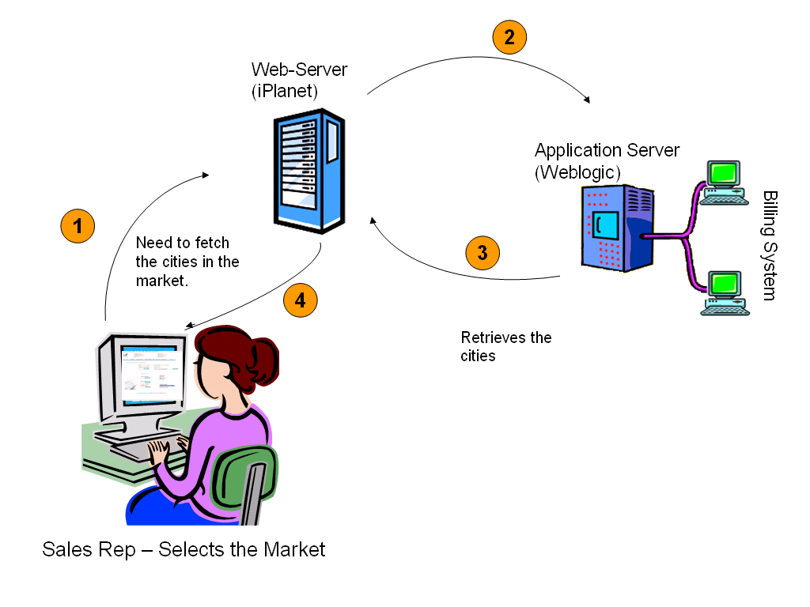

The Problem:

When the sales representative selects the Market, a call is made to the backend system. A request is been submitted. The page refreshes and then the page is loaded with service cities returned by backend system.
There may be many other fields in the same form, which may perform same kind of action. For all the request, if the page refreshes – then the representative need to have a coffee break.

Solution: AJAX

AJAX is the solution for these kinds of problem. I introduced AJAX in this scenario. With AJAX, a request is made to the server, but the page doesn’t refresh. The AJAX will wait for the server response and display the result which the request is processed.
Have a look at the screenshot

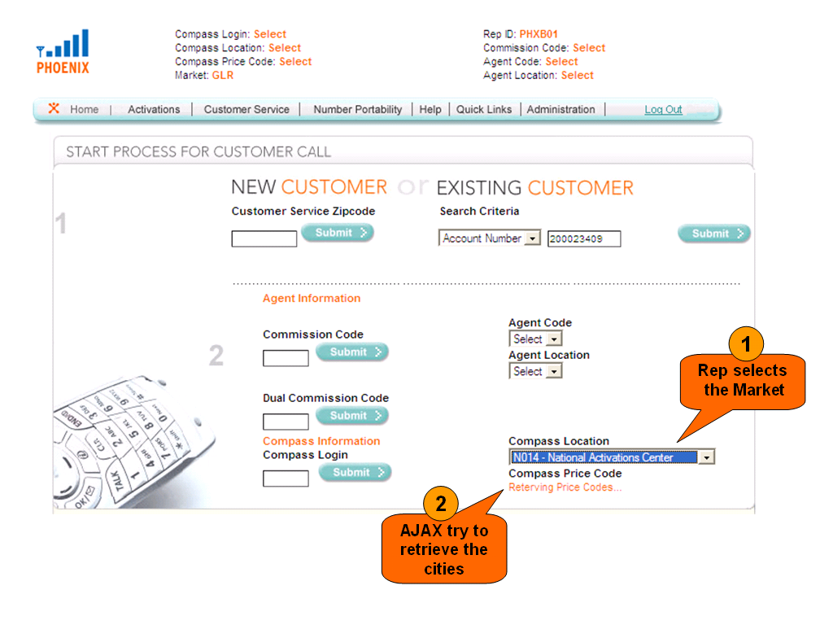
Once, the cities are returned by the server, they are displayed to the representative. But the page doesn’t refresh. It looks, like standalone application. 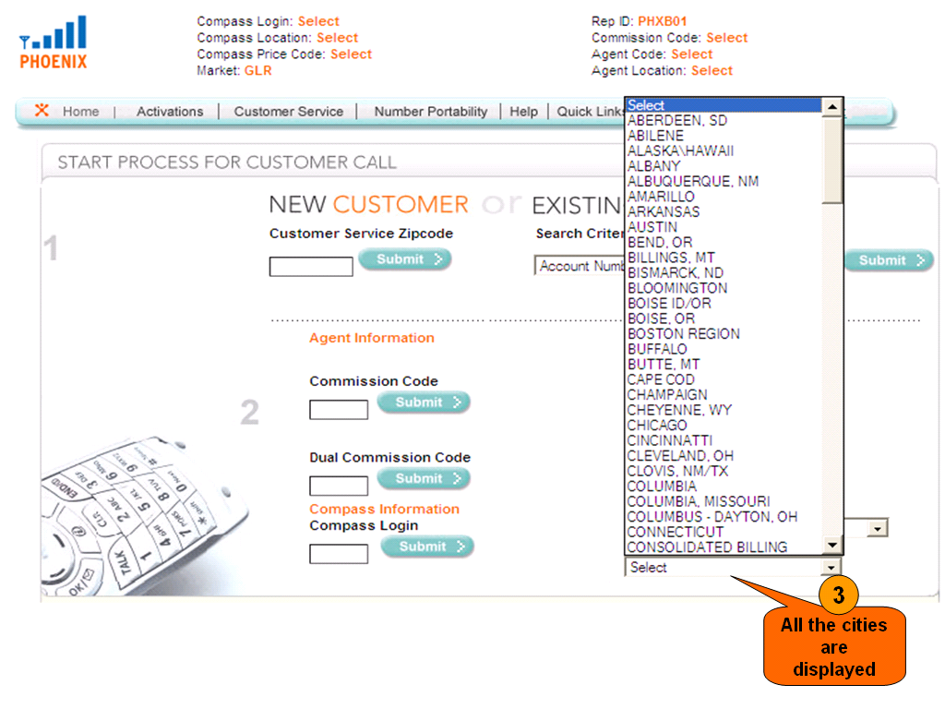

Now let’s get into actual business, let see how to code for it. But before that, let’s understand the existing model. This Application makes use of typical J2EE model.
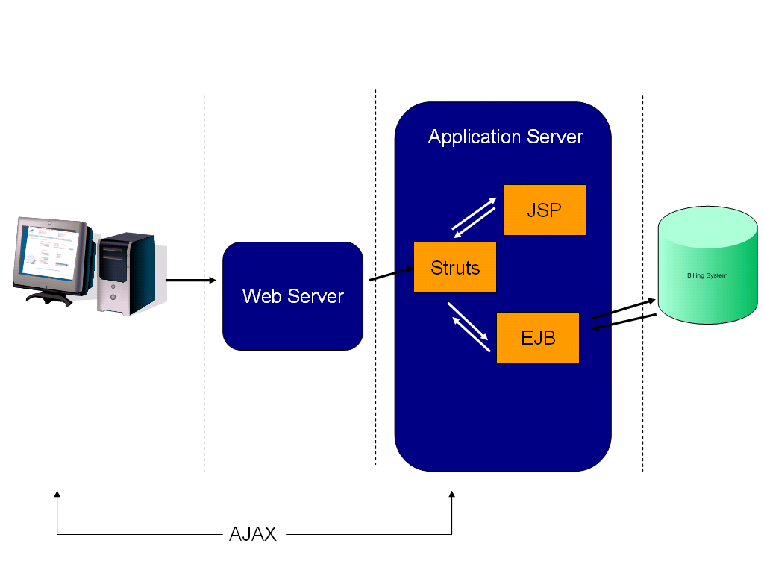
Since, the existing functionality already exists. I would be concentrating on “How to make call to Struts action from AJAX”. If I am able to do that, then this will resolve my problem.

Let’s do it step by step.

- User Selection: As soon as user selects Market combo box. I will invoke a JavaScript function (AJAXlookupPriceCodes).

Home.jsp
<td style = "padding-top: 0px;" valign = "top">
<span class = "bold">Compass Location</span>
<br>
<html:select property = "user.compassUser.locationFormat" onChange="AJAXlookupPriceCodes(this.value);">
<html:options collection = "compLocations" property = "value" labelProperty = "label"/>
</html:select>
<br>
<span class = "bold">Compass Price Code</span>

<br>
<span class = "orangeBold">
<div ID="AJAXPriceCodeName">
<html:select property = "user.compassUser.priceCode">
<html:options collection = "compPriceCodes" property = "value"
labelProperty = "label"/>
</html:select>
</span>
</div>
</td>

- Call Struts Action : The objective of AJAXlookupPriceCodes is to make a call to struts action and through AJAX.

Home.jsp

…..
…..

/*
* function: AJAXlookupPriceCodes
*
* this function accepts a Compass Location as it's input and performs an AJAX call to the server
* in order to look up the related Cities for the specified Compass Locations.
*/

// request object
var lookupCmpPriceCodeReq;

function AJAXlookupPriceCodes(location) {
(a) document.getElementById('AJAXPriceCodeName').innerHTML = '&nbsp;';
(b) if (window.ActiveXObject) { // IE
(c) lookupCmpPriceCodeReq = new ActiveXObject("Microsoft.XMLHTTP");
(d) if (lookupCmpPriceCodeReq) {
(e) document.getElementById('AJAXPriceCodeName').innerHTML = 'Reterving Price Codes...';
(f) lookupCmpPriceCodeReq.onreadystatechange = processPriceCode;
(g) lookupCmpPriceCodeReq.open("GET", "${contextPath}/main.do?dispatch=lookupPriceCode&location="+location, true);
(h) lookupCmpPriceCodeReq.send();
}
}
}
……
……

(a) Clear the AJAXPriceCodeName div with space. (Don’t worry about this, concentrate on other sections).
  - Check if the browser is compatible with ActiveXObject.
  - Get the request object for XMLHTTP
  - Check if you got successful request object.
  - Display message, while processing the request (Refer above screens)
  - Once we get a successful response from the server, call processPriceCode JavaScript function (I will let you know about this function shortly).

Properties
Property | Description
onreadystatechange | Event handler that fires when the state of the request object changes.
readyState | Returns values that indicate the current state of the object.
responseText | String version of the response from the server.
responseXML | DOM-compatible document object of the response from the server.
status | Status code of the response from the server.
statusText | Status message returned as a string.

  - Call the respective Struts Action.
  - Push the request.

Methods
Method | Description
Abort() | Cancels the current HTTP request.
getAllResponseHeaders() | Retrieves the values of all the HTTP headers.
getResponseHeader("headerLabel") | Retrieves the value of an HTTP header from the response body.
open("method", "URL"[, asyncFlag[, "userName"[, "password"]]]) | Initializes an MSXML2.XMLHTTP request, specifying the method, URL, and authentication information for the request.
send(content) | Sends an HTTP request to the server and receives a response.
setRequestHeader("label", "value") | Specifies the name of an HTTP header.

Now at the end of this, a call is made to the Struts action and the AJAXlookupPriceCodes, wait for the response from the server. In this mean time, “Retrieving price codes…” is displayed to the user.
- Struts Action : The Strut Action is responsible to
- Receive the request
- Perform additional validation
- Call the backed system thought EJB
- Generate the response XML
- Send back to the client.

MainAction.java
…..
…..

public ActionForward lookuppricecode(ActionMapping mapping, ActionForm actionForm,
HttpServletRequest request, HttpServletResponse response) {

TeleposContext tContext=TeleposSessionUtil.getTeleposContext(request);
(a) String locationFormat=(String)request.getParameter("location");
String compassMarket="";
(b) if (locationFormat==null) {
// in case no zip code was return error
log.error("Unable to get the Compass Market.");
response.setStatus(response.SC_BAD_REQUEST);
return null;
}

// populate response object with result XML
response.setContentType("text/xml");

try {
(c) String priceCodes = generateMktPriceCodes(compassMarket, tContext); // Business Logic to get the cities.

(d) PrintWriter writer = response.getWriter();
writer.print("<?xml version='1.0' encoding='ISO-8859-1'?>");
writer.print("<PriceCodeLookup>");
writer.print("<CompassMarket>" + compassMarket + "</CompassMarket>");
writer.print("<price_code>" +priceCodes + "</price_code>");
writer.print("</PriceCodeLookup>");
(e) writer.flush();
writer.close();
response.setStatus(response.SC_OK);

} catch (Exception e) {
e.printStackTrace();
response.setStatus(response.SC_NOT_FOUND);
log.error("IO error when writing to the response.");
}
return (null);
}
/**
……
……

Process the Response XML : Once the response is sent back to the client, as mentioned above processPriceCode() will be called to process the response XML.

Home.jsp
…..
…..

/*
* function: processPriceCode
*
* This function processes the AJAX request for the PriceCodes name lookup by Compass Location.
* It is called by the browser when the status of the request object changes.
*/

function processPriceCode() {
(a) if (lookupCmpPriceCodeReq.readyState == 4) { // Complete
(b) if (lookupCmpPriceCodeReq.status == 200) { // OK response
(c) xml = lookupCmpPriceCodeReq.responseXML;
(d) priceCodes = xml.getElementsByTagName("price_code")[0];
(e) if (priceCodes != null &&
priceCodes.firstChild != null) {

priceCodes = priceCodes.firstChild.data;
var pricecodeArray=priceCodes.split('|');
var priceCodeHtml="<select name='user.compassUser.priceCode'><option value=''>Select</option>";
// Ignore this logic.. used for my specific requirement.
for(ctr=0;ctr<pricecodeArray.length-1;ctr++)
{
var data=pricecodeArray[ctr].split("~"); priceCodeHtml=priceCodeHtml+"<option value='"+data[0]+"'>"+data[1]+"</option>";
}
priceCodeHtml=priceCodeHtml+"</select>";
}
else {
priceCodeHtml="No price code found.";
}
(f) document.getElementById('AJAXPriceCodeName').innerHTML = priceCodeHtml;
}
}
}
……
……

- Check the request is in Read state.
The event handler that you created for the onreadystatechange method is the place to focus on loading and error handling. This is the time to start thinking of the users and provide feedback about the status of the content with which they're interacting. In the example, I provide feedback for all the loading status codes and some basic feedback for the error handling status codes that occur most frequently. To indicate the current state of the request object, the readyState property includes the values shown in the following table.
Value | Description
0 | Uninitialized. The object is not initialized with data.
1 | Loading. The object is loading its data.
2 | Loaded. The object has finished loading its data.
3 | Interactive. The user can interact with the object even though it's not fully loaded.
4 | Complete. The object is completely initialized.

The W3C has quite a long list of the HTTP status code definitions. I chose two status codes:
- 200: The request has succeeded.
- 404: In case the server hasn't found anything matching the requested file.

- Check the status of the response. When the status code is equal to 200, meaning that the request has succeeded, the response is ready to be parsed.
- Get the response XML object.
- From the response XML object, get the tag value (this will get data inside the tag).
- Process the data, and generate the desired output html format. (I used a select option).
- Display the output in the innerHtml ('AJAXPriceCodeName').

At the end of this process, a combo box will be generated with cities and codes. This will be displayed to the user. Isn’t that marvelous. You should try simple programs.. Like Hello World, to start with. ☺

Case Study 2: Validating Foundation Account Number (FAN)

On the same page, there was a need to validate an account number dynamically. The user need not submit a request. I should happen on the fly. Take a look at the screen shot.

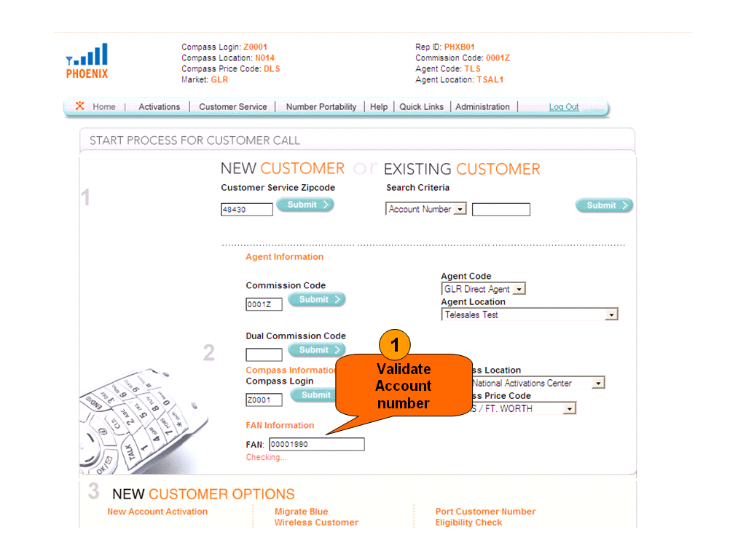
Once the account number is validated, the user information is shown to sales representative, with out submitting the page.
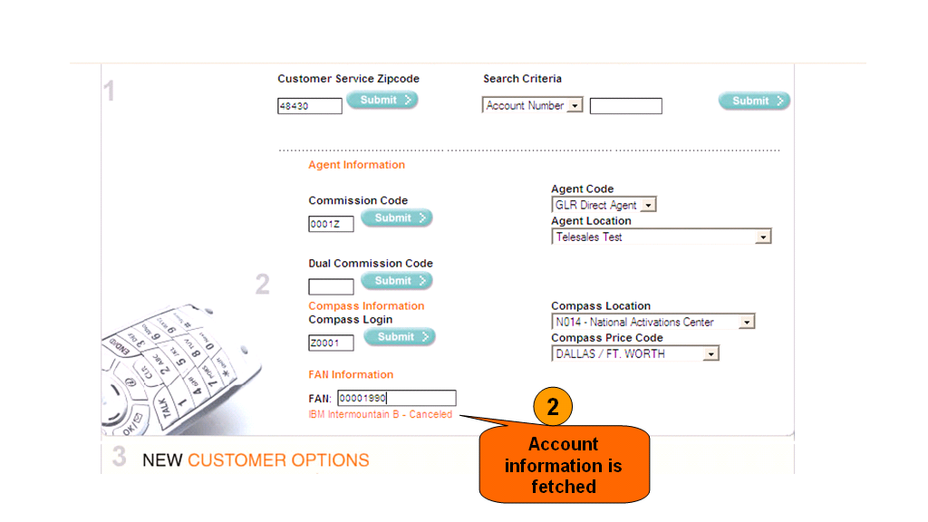
The implementation of account number validation is also in the similar lines with what we saw in the Case Study 1. I have attached both Home.jsp and MainAction.java, for your reference.
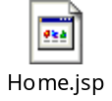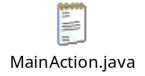

Conclusion:
Although AJAX allows us to build new and improved ways of interacting with a Web page, as developers we need to remember that the product is not about the technologies; it's about the users and how they interact with the product. Without the users, the projects we build would have no purpose. With that principle in mind, we can assess what technologies to use and when to use them in order to create an application that's beneficial to all who use it.

About Author:

Lovin Vergheese
Principal Software Engineer
FCGI Software Services
Email : lvergheese@fcg.com
Phone : (678)-229-1158
Some websites, which uses AJAX:


